**An Excitable Model of Internal Symmetry**

**Breaking in Dictyostelium discoideum**

A Research Thesis written for

**kettering university**

and submitted to

**KETTERING UNIVERSITY**

in partial fulfillment

of the requirements for the

degree of

**BACHELOR OF SCIENCE IN Applied Physics**

by

**Cody Grant**

2016

Student

Faculty Thesis Advisor

Committee Member

**DISCLAIMER**

This thesis is submitted as partial fulfillment of the graduation requirements of Kettering University needed to obtain a Bachelor of Science in Applied Physics Degree.

The conclusions and opinions expressed in this thesis are those of the student author and do not necessarily represent the position of Kettering University or anyone else affiliated with this culminating undergraduate experience.

**PREFACE**

This thesis represents the capstone of my five years combined academic work at Kettering University and past work experiences. My Culminating Undergraduate Experience provided the opportunity for me to use the knowledge and skillset learned while at Kettering to manage a project of this magnitude.

Although this thesis represents the compilation of my own efforts, I would like to acknowledge and extend my sincere gratitude to the following persons for their valuable time and assistance, for without whom the completion of this thesis would not have been possible:

1. Dr. Gillian Ryan; Assistant Professor of Physics, Kettering University; Research Thesis Advisor

2. Kiran Vekaria; Applied Physics/Applied Mathematics Major, Kettering University; Lab Member

**TABLE OF CONTENTS**

DISCLAIMER 2

PREFACE 3

LIST OF ILLUSTRATIONS 5

I. INTRODUCTION 6

Problem Topic 6

Background 6

Criteria and Parameter Restrictions 7

Methodology 8

Primary Purpose 9

Overview 9

II. CONCLUSIONS & FUTURE WORK 11

Conclusions 11

Future Work 12

III. BACKGROUND 14

IV. METHOD & APPROACH 24

Model 24

Linear Stability Analysis 28

V. RESULTS 37

REFERENCES 41

GLOSSARY 43

**LIST OF ILLUSTRATIONS**

**Figures Page**

1. Different functions of Actin 15

2. Time-lapsed images of a Dictyostelium Discoideum cell treated with Latrunculin A 18

3. Transition of a cell from the PTEN state to the PIP3 state 20

4. One period of transitions from the PTEN state to the PIP3 state, and back to the PTEN state 21

5. Reaction Diffusion Model of PIP3, PTEN, and hypothesized inhibitor X 25

6. Linear Stability Analysis possible steady state points 30

7. Period graphs; varying kt from 0.001 to 0.2 and rt1 from 0.1 to 20. 37

8. Period graphs; varying rp1 from 1 to 200 and rp0 from 1 to 200. 39

**Tables Page**

1. Brief descriptions of the parameters and excludes noise and diffusion 26

**I. INTRODUCTION**

**Problem Topic**

Eukaryotic cells, or animal cells, have an ability to self-organize internal mechanisms to create a protruding ‘front’ that moves the cell towards external signals, such as food. Gaining an understanding of how cells organize themselves may lead to important insight that may result in outcomes like: slowing down the spreading of cancer cells or speeding up healing processes inside the body.

**Background**

In biology, a significant area of research investigates how the living cell’s functions arise spontaneously from internal network reactions, and a fundamental example of this is cell motility. We are researching Dictyostelium Discoideum, or Dict D, cells and their internal signal in the absence of external cues. Most cells are polarized into two sides, a protruding ‘front’ and a retracting ‘tail’, and in Dict D cells the front corresponds to the PIP3 signal and the tail is the PTEN signal.

The Arai group has shown that there was an internal symmetry breaking between PIP3 and PTEN when no external cues are available. This means that PIP3 and PTEN are not found in the same locations, and the Arai group assumed this meant that they were mutually inhibitive (Arai et al., 2010). This is a very interesting idea, and ended up sparking interest in many research groups. A group of researchers lead by Gerisch determined that there has to be an absence in PTEN before PIP3 can populate and initiate a wave across the membrane as PTEN inhibits PIP3. The other findings from this study was that the system exhibits excitable, wave-like behavior (Gerisch, Schroth-Diez, Müller-Taubenberger, & Ecke, 2012). The Gerisch team created a kymograph, which can be seen in Figure 3, and this sparked interest in our group due to the fact that during transitions the green (PIP3) front is not touching the red (PTEN) front (Gerisch et al., 2012). The graphs show that PIP3 does not follow immediately after PTEN, as seen in Figure 3, and this is interesting because if the two were mutually inhibitive, that would be the case. We assume the fact that they are not touching is due to a third signal that is not being looked at, which that inhibits PTEN and allows PIP3 to accumulate on the membrane. The same research group did a similar study on giant cells and found that if two initiated PIP3 wavefronts hit one another, then the waves annihilate (Gerhardt et al., 2014). This last result provides additional evidence that these are excitable waves; and, therefore, it is an excitable system that can be modeled. The goal of this thesis is to develop a mathematical model of the PIP3 and PTEN oscillation within this system.

More information about the background can be found in Chapter III.

**Criteria and Parameter Restrictions**

The goal of the project is to develop a model that captures the observed experimental behavior of Dict D and its polarization events. There are two criteria to consider a parameter set as plausible or physical. The first being that the steady state point needs to have a complex eigenvalue that has a negative real component. Eigenvalues represent the system’s overall behavior at specific concentrations of the three signals, PIP3, PTEN, and hypothesized PTEN inhibitor X. The equilibrium point in a three equation system will have three eigenvalues, two complex eigenvalues and one real eigenvalue. Two complex eigenvalues with negative real components, and the third eigenvalue needs to be negative will determine a behavior that is periodic and stable, which matches the physical system being studied. The second criteria is that the complex eigenvalues results in a period near 200 seconds. The experimental data shows the systems period around 200 seconds (Gerisch et al., 2012).

**Methodology**

After development of a model, it would need to be studied for steady state points and their corresponding eigenvalues. This will determine if the model is worth pursuing further as it will show whether the model’s behavior matches the physical system’s behavior. Our model is a reaction diffusion model, consisting of a system of three rate equations. The three rate equations correspond to the PIP3 signal, the PTEN signal, and a hypothesized PTEN inhibitor X. The fact that this is a reaction diffusion model means that each of the three signals have terms (or reactions) that increase the concentration creation/depletion rate, and terms that decrease the concentration creation/depletion rate in an area. The signals also have diffusion terms to interact with the signals in the membrane around it.

Our method for examining our system of three equations for excitable behavior is known as Linear Stability Analysis. The system has steady state points, which is where the rate equations equal zero, and this analysis looks at a slight perturbation from the steady state points to determine how the system reacts near that steady state point. We are looking for steady state points with complex eigenvalues that have negative real components. We are also looking for parameter sets that have periods near 200 seconds.

More information about the model and method can be found in Chapter IV.

**Primary Purpose**

The thesis will develop and test a model for excitable, oscillatory behavior of PIP3 and PTEN signals in Dict D.

**Overview**

If the reader is looking for the most detailed story of this project, then the thesis should be read in the following order: Chapter III, Chapter IV, Chapter V, and lastly, Chapter II. However, if the reader is looking for the main points, then Chapter II following Chapter I should be sufficient. Chapter I briefly covers all of the topics covered in Chapters III, IV, and V.

Chapter II covers conclusions and future recommendations. This chapter covers the ramifications of the results. The chapter also covers what future work is expected to complete the project.

Chapter III covers the background in better detail. This chapter covers three physical systems. In this section, the reader will also find some physical parameters that were found from the physical system that will be used in the computer simulation.

Chapter IV covers the method and approach taken during the thesis work. The reader will find the model in much finer detail, and this is both in sketch and equation form. The reader will also find an explanation to linear stability analysis and how it relates to our specific model.

Chapter V covers some results found for the project. The reader will find some parameters have a larger effect on the period than others.

**II. CONCLUSIONS AND FUTURE WORK**

**Conclusions**

The goal of the project was to research and try to model some of the internal mechanics of Dictyostelium Discoideum motility. The thesis was a success, a model was created and plausible parameters were identified. However, multiple parameter sets were found that gave oscillatory behavior with the right period, which was the criteria. This model was heavily influenced by measurements reported in experimental papers. In previous work, it was found that there is an internal symmetry breaking between PIP3 and PTEN, it is hypothesized that a suspected third signal X plays a significant role in internal signal motility, and that the internal waves show to be excitable, which means it is an excitable system [Chapter III]. From this background, a system of three rate equations were created. However, the three equations had a total of 10 parameters which needed to be varied in a way that all possible solutions could be examined.

Some of the parameter results were examined and the period of the system is responsive to changes in the parameters rt1 and kt, parameters that regulated the on and off rates of PTEN, respectively. However, the period is less responsive to most of the other parameters that are being varied [Chapter V]. The most challenging section of the thesis research was trying to figure out a way we could accurately vary all the parameters and print off results that could be understood fairly easily.

The goal was to create an accurate model for the biological system. Though, the project did not fail, the project did not progress as far as initially envisioned. This could be extended by another student in the future, and s/he can determine if the model is a success or a failure.

**Future Work**

This work is a first step in modelling this phenomena. However, there is still work to do to find parameter sets that closely represent the experimental data collected. The first being an investigation into whether rt1 and kt are the only parameters to contribute significantly to the eigenvalues and period of the system, as seen in Figure 7. A rather simple way to determine that would be to conduct a more thorough variation of parameters across a wider range.

This leads into the next step, which is finding whole parameter sets based on criteria other than oscillatory behavior with a specific period. These parameter sets need to not only have a period of 200 s. The sets also need to make physical sense and specific units should be decided for each value to make the system as physically sound as possible. This means that when the parameter sets are used in the computer simulation of the model, the results should closely resemble the results to the experimental measurements.

The final step to this process would be to take those parameter sets and implement the system in the computer simulation of the model. The graphs and values generated from this final step should exhibit minor, if any, differences from the experimental data. It would need to include diffusion, and the simulation would produce 2D movies, which would look more like the experimental images of the cells. This would provide further restrictions on parameter selection. If one or more parameter sets are found that match this condition, then it can be said that our model is one way to model the physical system.

**III. BACKGROUND**

In biology, a significant area of research investigates how the living cell’s functions arise spontaneously from internal network reactions, and a fundamental example of this is cell motility. “Cell migration is a broad term that we use to refer to those processes that involve the translation of cells from one location to another.” (Cell Migration Gateway, 2014). Cell migration can occur in many different places and can happen for multiple reasons. An example of this would be a Dictyostelium Discoideum, or Dict D, cell, which is a type of slime mold that migrates towards nutrients. Other eukaryotic cell types migrate to generate new structures, layers, or organs, which can translate to healing a wound or an adolescent body growing. On the darker side of migration, abnormal migratory signals may have the wrong cell go to the wrong place. This happens during autoimmune syndromes, such as rheumatoid arthritis, in which the supporting tissue of the joint is destroyed. It also can happen during metastasis, in the case of cancer spreading, where tumor cells leave the primary tumor and migrate to create secondary tumors (Cell Migration Gateway, 2014). In the absence of external cues, it was found that random cell migration uses only internal signals to induce motile activity in random directions. Since intracellular processes are responsible for spontaneous signal generation, it is necessary to understand these processes in the absence of external stimuli (Arai et al., 2010).

Motile eukaryotic cells are typically polarized into two ‘sides’, a protruding ‘front’ and a retracting ‘tail’. The establishment of polarity is one of the first essential steps to cellular motility. The polymerization of cytoskeletal proteins occurs in the front of the cell, which causes the cell to move forward, or protrude. The driving mechanism behind the polarity of these cells is the actin system in the cortex (Gerisch et al., 2012). “Actin is an abundant structural [protein](http://www.ncbi.nlm.nih.gov/books/NBK21607/def-item/A7752/?report=objectonly) in eukaryotic cells that interacts with many other proteins.” (Lodish et al., 2000). The basic structure formed by actin is called an actin filament, and these actin filaments can bundle together to form an actin cytoskeleton. The filaments found in the cell cortex determine physical properties of the cell surface, such as shape, stiffness, and movement. Below, in Figure 1, is some different ways actin filaments can determine shape and other properties of the cell.

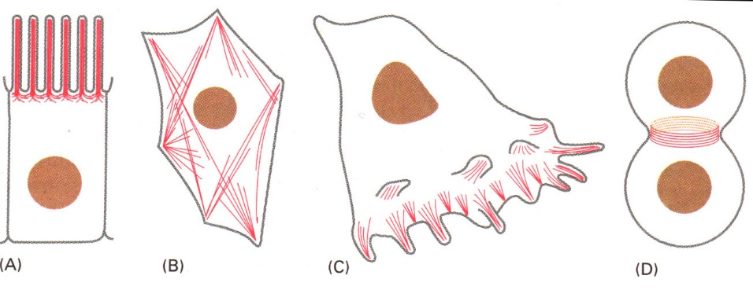

Figure 1. Different functions of Actin. The red lines are the actin filaments, and the brown circles are the nuclei. Depending on the internal signals, the actin filaments can change shape and structure of the cell. A. Used in epithelial cells for structure and support. B. Actin filaments are created in response to tension on the cell. C. Actin filaments are used to bleb the cell outward and move it forward, this is very similar to the system we are studying. D. Actin filaments are used for cell division. (CNU, n.d.).

The actin cytoskeleton is responsible for the mechanical forces and intracellular forces required for cellular motility. Typically, actin polymerization occurs over three phases. The three phases are a nucleation phase, an elongation phase and a steady state phase. The nucleation phase creates an actin nucleus, which is the start of new filaments. This can result from spontaneous nucleation or new filaments can be initiated by other signals in the actin signal pathway. The elongation phase is characterized by the growth of the filaments by the addition of actin monomers, which grows the actin filament, and this net growth at the front of the cell can lead to a force pushing the cell forward. Finally, during the steady state phase the actin filament will stay approximately the same size and actin monomers will constantly be added and subtracted from the actin filament. Additional signals can lead to the capping, branching, cross-linking, and severing of actin filaments to create complex actin structures throughout the cell, as shown in Figure 1. In summary, the actin will network together into long chains to form dynamic actin polymers (MBInfo Wiki, 2015). By studying interactions that lead to actin polymerization, we can begin to understand the internal mechanisms that govern cell speed in response to external stimulation. Ultimately, a comprehensive understanding of how cells move may lead to therapies that can speed up cells that heal the body, and slow down the cells that harm the body, such as cancer.

Dict D cells are used as a model cell system for eukaryotic cell motility. Dict D cells are easily cultured which make them easy for experimentalists to study. Dict D cells are also great to study because they are highly motile and their actin systems rapidly reorganize in response to external cues, such as nutrient gradients (Gerisch et al., 2012). This makes them ideal for studying motility and chemotaxis, or movement in response to external signals. However, these cells also spontaneously polarize when no external signal is present, which makes them interesting for studying internal polarization processes.

Dict D cells have two signals that are correlated with the ‘front’ and ‘back’ of the cell, respectively. The protruding ‘front’ of the cell has a high concentration of the lipid phosphatidylinositol [3,4,5] tris-phosphate (PIP3), which leads to actin polymerization. The retracting ‘back’ or ‘tail’ has a high concentration of the enzyme phosphatase tensin homolog (PTEN). PIP3 leads to actin polymerization and PTEN will deactivate PIP3 by converting PIP3 into PIP2, and PIP2 does not contribute to actin polymerization.

For all of the experiments we have studied as reference for our model, there are two fluorescent proteins that are used as tags, the back fluorescence is green and the front fluorescence is red. PIP3 is associated with the green tag, and PTEN is associated with the red tag. With these tags in place, the experimentalists can actually see the interaction of the opposing concentrations and record images on how the membrane changes over time. In a 2010 study, a group from Osaka University observed an internal symmetry breaking in Dict D after being treated with Latrunculin A, or Lat A (Arai et al., 2010). Lat A depolymerizes the actin filaments, which results in the Dict D cells are no longer motile and the internal mechanics can be studied with no external stimulus and no residual polarization of the cytoskeleton from previous signals (Gerisch et al., 2012). The Arai group observed that the red and green signals, PTEN and PIP3, could not occupy the same areas of the cell. Arai also observed the two signals separating and oscillating around one another. The group concluded this was internal symmetry breaking and suggested PIP3 and PTEN to be mutually inhibitive, which is shown in Figure 2 (Arai et al., 2010). With the conclusion that PIP3 and PTEN are mutually exclusive, many research groups found interest in the system (Gerhardt et al., 2014; Gerisch et al., 2012; Knoch, Tarantola, Bodenschatz, & Rappel, 2014). Other experimentalists studying the non-motile Dict D realized the cells underwent stages of instability that oscillated between two distinct states separated by propagating actin waves. Those two states were characterized by high concentrations of either PIP3 or PTEN along the substrate membrane of the cell (Gerisch et al., 2012).

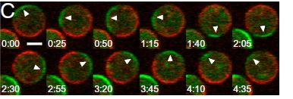

Figure 2. Time-lapsed images of a Dictyostelium Discoideum cell treated with Latrunculin A. The border is switching between PTEN (red) and PIP3 (green) in a periodic fashion. The two signals seem to be touching, suggesting that the two signals are mutually inhibitive (Arai et al., 2010).

Following the work of the Arai group, another group of researchers from the Max Planck Institute of Biochemistry concluded that PIP3 patterns oscillate similar to actin waves, and therefore PIP3 patterns and actin waves are linked together (Bretschneider et al., 2009; Gerisch et al., 2004). PIP3-rich and PTEN-decorated areas of the membrane suggest direct cross-inhibition of PIP3 and PTEN, which is similar to what the Arai research group concluded. However, in the Gerish experiment, the Lat A was washed out, and that means there were some changes in the system’s interactions. The Gerisch group successfully uncoupled actin from PTEN, but actin waves were still formed, suggesting that actin waves do not completely rely on PIP3 pattern oscillations. However, the periodicity of the actin wave changed with the uncoupling, and this change suggests that PTEN dynamics are linked to state transitions in actin systems. The experimental kymograph obtained from the Gerisch research group, as shown in Figure 3, displays a gap in between the PIP3 and PTEN signals. This gap suggests that PIP3 and PTEN are not mutually inhibitive as the Arai group concluded (Gerisch et al., 2012).

In Figure 3, below, the kymograph is believed to suggest a third signal in this process that creates a PTEN-free space for the PIP3 to populate, and this is due to the dark gap in between the red and green signals. However, PIP3 does not take over the cell every chance it has. Some of the PIP3 fluctuations will reach a supercritical level, and only when that happens will a wave a PIP3 sweep across the entire cell substrate. PIP3 will quickly diffuse and PTEN will take over and the whole process starts again. The rest of Figure 3 is showing how only PIP3 patches that hit critical concentration will amplify and create propagating waves that take over the entire cell’s membrane (Gerisch et al., 2012).

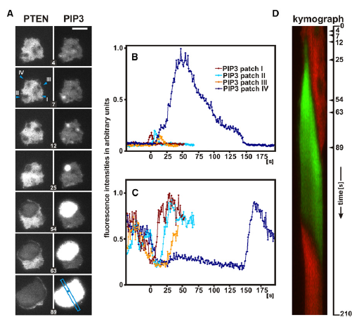

Figure 3. Transition of a cell from the PTEN state to the PIP3 state. (A) Four PIP3 patches have shown up in PTEN-absent areas. Patches I-III quickly disappear. Patch IV hits the critical concentration and initiates a wave that takes control of the whole cell. (B) Graph form of the PIP3 patches. As shown in the right column of A. (C) Graph form of the PTEN holes, which correspond to the PIP3 patches. As shown in the left column of A (D) Kymograph showing evolution of PTEN (red) and PIP3 (green) in the scan direction as shown in A (blue bar). Arrowheads at the vertical axis indicate times of the respective frames in A. The kymograph shows that once PIP3 has taken the whole cell over, there is a short time before PTEN suppresses PIP3 completely. Bar, 10 micrometers. (Gerisch et al., 2012).

With this information in mind, it can be suggested that the whole system acts like an excitable model. PIP3 needs to be excited to a critical level to create wave propagation. The PTEN concentration is excited enough to inhibit all of the PIP3 via its own propagating wave which follows the PIP3 wave, as shown in Figure 4 (Gerisch et al., 2012).

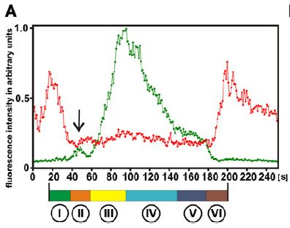

Figure 4. One period of transitions from the PTEN state to the PIP3 state, and back to the PTEN state. The arrow points to a transient increase in PIP3 within the hole of PTEN where a wave is eventually initiated. The red is the PTEN intensity and the green is the PIP3 intensity. There are six phases to the process: (I) holes found in PTEN concentration, (II) appearance of PIP3 into said holes, (III) PIP3 concentration increasing to the point of critical concentration, (IV) PIP3 wave traversing the membrane, (V) membrane completely covered by PIP3, and (VI) PTEN re-enters close to initial PIP3 site (Gerisch et al., 2012)

This process happens in cycles and it is similar every time it happens, and this suggests that the system is periodic in nature. The group did a similar study in 2014 on giant cells, which have a diameter of more than 30 µm, as opposed to the regular cells with a diameter of 10 µm. This study showed that many of the properties of giant cells were nearly identical to that of the regular cells. One fascinating discovery was found when two PIP3 waves collided on the cell’s membrane. Giant cells have enough membrane surface area that allows two PIP3 patches to accumulate the critical concentration at the same time. This causes two different waves traversing the membrane surface from two different locations. Typically mechanical and electromagnetic waves will pass through one another; however, when the PIP3 waves meet, the waves annihilate one another upon collision. The PIP3 wave “turns on” its concentration in that area of a cell instead of moving a pulse of concentration to that area of a cell. The adding of concentration would be expected from a superposition of signals for waves similar to optical waves, and these waves would come in contact and pass through one another. However, PIP3 waves annihilate upon impact, which means that the waves act as an activation versus a transportation of the signals. This observation further supports the hypothesis that PIP3 and PTEN waves are a result of an excitable activation mechanism, with a characteristic recovery or refractory time between excitations (Gerhardt et al., 2014).

The polarized system in Dict D is excitable and it has a periodic nature, therefore, a mathematical model of the system can be created. This system will be attempted to be modeled like a reaction-diffusion model, with three separate, but interacting, signals. To create a mathematical model, the physical characteristics of the system needs to be understood and the parameters need to be found. As seen in the method & approach section, after creating a set of equations, linear stability analysis can be set up to find most of the parameter sets that provide possible realistic results. However, any numbers that can be obtained from the experimental data should be used.

Some physical information about this system is directly available from existing literature. For example, the kymograph on Figure 3 led to an estimation of the relative wavespeeds of both PIP3 and PTEN. It was found that the PIP3 wavefront is about 0.107 μm/s and the PTEN wavefront about 0.434 μm/s (Gerisch et al., 2012). A second piece of information was found from a combination of graphs from both the Arai experiment and one of the Gerisch experiments. It was found that the approximate period of PIP3 and PTEN is about 100 seconds, and that makes the period for the whole cycle about 200 seconds (Gerisch et al., 2012). These pieces of information can be used to confirm whether our model and parameter sets are practical when compared to the experimental results.

**IV. METHOD AND APPROACH**

**Model**

The presented works attempt to model the PIP3 and PTEN interaction in a non-motile Dict D cell via reaction-diffusion equations. It is believed that in the PIP3 and PTEN interaction there is a third signal (X), which inhibits PTEN. The inhibitor is hypothesized based on PIP3 and PTEN dynamics shown in Figure 3. The PTEN has to be inhibited and leave free space on the substrate for the PIP3 to propagate, as it is known that PTEN directly inhibits PIP3. There is also a kymograph in Figure 3 that shows PTEN leaving an area before PIP3 has arrived. This is believed to be caused by the third signal X, which is an excitable inhibitor of PTEN (Gerisch et al., 2012).

It is hypothesized that once X has inhibited PTEN, PIP3 then has the opportunity to increase concentration in those PTEN-free spaces. These PIP3 spots have the ability to spread across the cell membrane, but only if it can hit a critical concentration in that location. If the critical concentration is reached, the PIP3 spot creates a propagating wave, as seen in Figure 3. The ability to create a propagating wave, combined with the behavior of the wave described in the Background section, suggests that this is an excitable system. An excitable system is something we can model using differential equations. With the X signal in play, it is assumed that PIP3 inhibits the X signal’s ability to self-recruit, and X inhibits PTEN. It is assumed that PIP3 and X self-recruit to the membrane, which is a form of positive feedback. The X signal inhibits PTEN and self-recruits, limiting PTEN accumulation. In the absence of PTEN, PIP3 self-recruits and inhibits the X signal, and eventually is inhibited by PTEN if the PIP3 spot does not hit critical concentration to initiate a state transition, or a wave front. If the PIP3 spot does hit critical concentration, it sends out a wave and takes control of the cell and eventually is taken over by PTEN again. These dynamics are illustrated below in Figure 5.

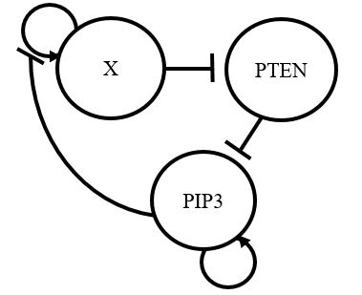

Figure 5. Reaction Diffusion Model of PIP3, PTEN, and hypothesized inhibitor X. The X signal inhibits PTEN and self-recruits. PTEN inhibits PIP3, and PIP3 self-recruits and inhibits the self-recruitment cycle of X.

The above model simulates the interactions between the two lipids PIP3 and PTEN, and the third assumed signal, X. For simplicity in the equations, PIP3 and PTEN are written as P and T, respectively. The third signal, X, is the concentration of the hypothesized inhibitor. This model is assumed for Dict D cells after a Lat A treatment and washout. Therefore, the cell we are trying to model is not motile. The model is 2D and modelling signals in just the substrate membrane, with each cell having an approximate diameter of 10 micrometers. The rate equations that are being investigated for the system, in Figure 5, are:

$\frac{∂X}{∂t}=\left(r_{0X}+r_{2X}X^{2}\right)e^{-\frac{P}{P_{0}}}-k_{X}X+{D_{X}∇}^{2}X+s$ (1)

$\frac{∂P}{∂t}=r_{0P}+\frac{r_{1P}P}{A+P}-k_{P}TP+D_{P}∇^{2}P$ (2)

$\frac{∂T}{∂t}=r_{1T}P-k_{T}XT+D_{T}∇^{2}T$ (3)

The above equations are reaction-diffusion equations. This means the rate of each of our components are dependent on diffusion and reaction terms. Production reaction terms are terms that increase the rate of that signal. Degradation reaction terms are terms that reduce the rate of that signal. Table 1, below, quickly summarizes the parameters:

Table 1

Brief descriptions of the parameters and excludes noise and diffusion.

|  |  |
| --- | --- |
| Term | Description |
| $$r_{0X}$$ | Constant on-rate for X |
| $$r_{2X}$$ | Quadratic on-rate for X |
| *P0* | Critical concentration of P |
| *kx* | Linear off-rate for X |
| $$r_{0P}$$ | Constant on-rate for P |
| $$r_{1P}$$ | Linear on-rate for P |
| $$k_{P}$$ | Linear off-rate for P |
| $$r_{1T}$$ | Constant on-rate for T |
| $$k_{T}$$ | Linear off-rate for T |
| *A* | Half-maximal concentration constant |

Equation 1 describes the dynamics of the X signal on the membrane. It has two production reaction terms, a degradation reaction term (or an inhibition term), a diffusion term, and a term for white noise (s), respectively. The production terms in the first equation almost act as a single object, and those terms allow for spontaneous accumulation of X, as well as the self-recruitment of X. However, the additional exponential function multiplied to those terms is the idea that the PIP3 concentration actually inhibits the X signal’s ability to self-recruit. Being that X self-recruits, an inhibition mechanism is required to recover the excitable behavior observed experimentally. X is removed from the membrane at a constant rate per concentration (kx), and an exponential damping term is applied to the X production, so that X stops accumulating in the membrane as PIP3 accumulates. Diffusion terms, Dn, are included for all three signals to govern the spread of that concentration to the nearby membrane. Diffusion rates determine how quickly each of the three signals diffuse throughout the cell membrane.

Equation 2 describes the dynamics of PIP3 in the membrane. It has two production reaction terms (the latter of the two is a Hill function), a degradation reaction term, and a diffusion term, respectively. The Hill function regulates the on-rate of PIP3 so that its concentration slowly builds until it hits a critical value. Once that value is achieved, the concentration grows very quickly, and once it is past the critical concentration, the growth slows back down. The A in the Hill function is the half-maximal concentration constant and has yet to be determined. The inhibition term is different in this equation, it is actually the interaction between PTEN and PIP3. The more PTEN concentration there is, the faster PIP3 is inhibited from the membrane. There is zero inhibition in PIP3 in the absence of PTEN, but PTEN is recruited with PIP3, which is the first term in equation 3. This can be seen in the physical system with the help of Figure 3, which shows that PTEN re-accumulates in the membrane in the same location that PIP3 initially took over (Gerisch et al., 2012).

Equation 3 describes the dynamics of PTEN in the membrane. It has a production reaction term, a degradation reaction term, and a diffusion term, respectively. This production term in this equation states that the higher the PIP3 concentration is, the higher the PTEN on-rate becomes. The degradation term is an interaction between PTEN and X. The more X concentration that is present, the more inhibited the PTEN rate becomes. In general, any term that has a negative sign in front of it, or is being subtracted from the rest of the terms, is the degradation terms for the rate. In these cases, all but the X degradation term are interactive terms.

Some parameter values are available from existing literature. Image analysis work had been done and it was found that the PTEN front (0.434 μm/s) is about four times faster than the PIP3 front (0.107 μm/s), and it is inferred from the analysis that PTEN’s diffusion coefficient is about four times greater than PIP3’s diffusion coefficient (Gerisch et al., 2012). Ideally, this model would be tested via computer simulation. However, as that there are many unconstrained parameters, some analytical calculations first need to be completed to limit the number of parameters, as well as the limiting the parameter ranges for the computer to give us useful results.

**Linear Stability Analysis**

The analysis that will be used to investigate the parameter ranges of this model is called Linear Stability Analysis. This analysis is used to potentially narrow down the parameter set, or at least show that only a few parameter sets will work to recover the excitable behavior observed experimentally.

Linear Stability Analysis is used to look at how a dynamic system reacts at steady state points, or fixed points. Steady state points are points in the system where the time derivatives of all the variables (the differential equations) equal zero. For this model, a stable steady state point is desired. If the system experiences a small perturbation from a stable steady state point, which may result from small fluctuations in the concentration of a signal, the system will move back towards the steady state point. A small perturbation from an unstable fixed point will move away from the fixed point and not return to that value. A fixed point could be seen as a marble on the center of a bowl. If the point is stable, then the bowl is right side up, and if the marble is moved from the center, it will roll back to the center. If the point is unstable, the bowl is upside down, and if the marble is moved away, it will roll off the bowl. In Linear Stability Analysis, the system is reduced to zero dimensions and that means the diffusion terms are not needed.

The first step in the analysis is to identify the steady state points, and then to see whether or not those stable points are unstable or stable. In order to ascertain a steady state point’s stability, it is necessary to find the eigenvalues for the model. The eigenvalues also tell us about the system’s behavior at that point in parameter space, such as whether it oscillates or not. The eigenvalues can be real, complex, or purely imaginary, as shown below in Figure 6.

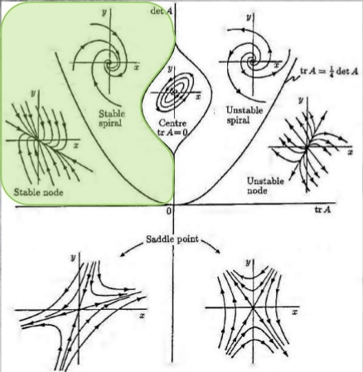

Figure 6. Linear Stability Analysis possible steady state points. The values shaded in green and above the parabola are of the most interest. Everything above the parabola is periodic. Everything to the left of the y-axis and above the x-axis is stable. The A represents the Jacobian of the steady state point; examples can be found in equations 21 and 23. (Slideshare, 2012).

Steady state points that have real eigenvalues with positive values will progress out towards infinity when perturbed. Steady state points that have real eigenvalues with negative values will progress from the perturbed position to the stable point when perturbed. Therefore, positive real eigenvalues are unstable because a small perturbation from the steady state point will send the signal to infinity, and negative real eigenvalues are stable because the signal will be sent back to the steady state point. The systems with these types of eigenvalues are not oscillatory.

A steady state point with complex eigenvalues is oscillatory. In response to perturbation, these steady state points exhibit spirals, circles, or limit cycles. If the real part of the eigenvalues does not equal zero then the trajectories near the steady state point look like spirals. This can be seen in Figure 6 above the parabolic curve. Complex values are a real part added/subtracted to an imaginary part. If the real part is positive then the point is unstable and if it is negative then it is stable, as stated above. When the real part is negative, concentrations near the steady state point act like a damped oscillator because the amplitude decreases every period until it settles at the stable steady state point. When the real part is positive, concentrations near the steady state point act like a driven oscillator for the opposite reasons.

Steady state points with imaginary eigenvalues are a special case of complex eigenvalues where the real part of the eigenvalue equals zero. They create phase plots that make circles or limit cycles. Limit cycles do not have to be circles, but are closed paths on a graph. There are different types of limit cycles. Circles and limit cycles are truly oscillatory systems. They are not damped oscillators, they are just oscillators. Once these systems are slightly perturbed from the steady state point, they will not eventually settle back down to the steady state point or shoot off to infinity. They will revolve around the steady state point, staying on that closed path, forever.

To make the model realistic for this system, complex eigenvalues with negative real components are needed. The system needs to be periodic and make its way back to the stability point if allowed to relax. The eigenvalues we are looking for are something that looks like a damped oscillator, which is something that is periodic, but the amplitude decreases each period until it returns back to zero.

Remembering that P is the concentration of PIP3, T is the concentration of PTEN, and X is the concentration of the unknown we are assuming exists, our system of three equations is (excluding diffusion and noise):

$\frac{∂X}{∂t}=\left(r_{0X}+r_{2X}X^{2}\right)e^{-\frac{P}{P_{0}}}-k_{X}X$ (4)

$\frac{∂P}{∂t}=r_{0P}+\frac{r_{1P}P}{A+P}-k_{P}TP$ (5)

$\frac{∂T}{∂t}=r_{1T}P-k_{T}XT$ (6)

Next, we find the steady state points P*, T*, and X* which occur when:

$\frac{∂X}{∂t}=\frac{∂P}{∂t}=\frac{∂T}{∂t}=0$ (7)

We want to define a new set of equations:

$\frac{∂X}{∂t}=r(P, T, X)$ (8)

$\frac{∂P}{∂t}=m(P, T, X)$ (9)

$\frac{∂T}{∂t}=n(P, T, X)$ (10)

At the steady state points, the new equations are equal to zero:

$r\left(P^{*},{ T}^{*}, X^{*}\right)=m\left(P^{*},{ T}^{*}, X^{*}\right)=n\left(P^{*},{ T}^{*}, X^{*}\right)=0$ (11)

Finishing the linear stability analysis is necessary for determining the point’s stability, and adding the small perturbation to the steady state point is the first step in that. Looking at only the steady state point will give a false sense of security, as the stable points will be stable and the unstable points will be pseudo-stable. Pseudo-stable means the steady state point looks stable, but when slightly perturbed, it acts unstable. Therefore, everything looks stable. However, slightly perturbing the fixed point can fix all of that because the stable ones will still act stable, but the unstable points will no longer act pseudo-stable. Adding some perturbation follows:

$X= X^{*}+s$ (12)

$P= P^{*}+q$ (13)

$T= T^{*}+w$ (14)

The derivatives of the perturbations are equal to the differential equations in equations 8-10. This is due to the derivatives of the steady state points equaling zero, as implied in equation 11. Therefore, the equations to come out of this are:

$\frac{∂s}{∂t}=r\left(P^{*}+q,{ T}^{*}+w, X^{*}+s\right)$ (15)

$\frac{∂q}{∂t}=m\left(P^{*}+q,{ T}^{*}+w, X^{*}+s\right)$ (16)

$\frac{∂w}{∂t}=n\left(P^{*}+q,{ T}^{*}+w, X^{*}+s\right)$ (17)

A first order Taylor Series Expansion on equations 15-17 would lead to:

$\frac{∂s}{∂t}=r\left(P^{*},T^{*}, X^{*}\right)+\frac{∂r}{∂P}\left(P^{*},T^{*}, X^{*}\right)+\frac{∂r}{∂T}\left(P^{*},T^{*}, X^{*}\right)+\frac{∂r}{∂X}\left(P^{*},T^{*}, X^{*}\right)$ (18)

$\frac{∂q}{∂t}=m\left(P^{*},T^{*}, X^{*}\right)+\frac{∂m}{∂P}\left(P^{*},T^{*}, X^{*}\right)+\frac{∂m}{∂T}\left(P^{*},T^{*}, X^{*}\right)+\frac{∂m}{∂X}\left(P^{*},T^{*}, X^{*}\right)$ (19)

$\frac{∂w}{∂t}=n\left(P^{*},T^{*}, X^{*}\right)+\frac{∂n}{∂P}\left(P^{*},T^{*}, X^{*}\right)+\frac{∂n}{∂T}\left(P^{*},T^{*}, X^{*}\right)+\frac{∂n}{∂X}\left(P^{*},T^{*}, X^{*}\right)$ (20)

We know from equation 11 that the first terms of equations 18-20 are zero. Then the Jacobian matrix can be constructed:

$J_{\left(P^{*},T^{*}, X^{*}\right)}=\left(\begin{matrix}\frac{∂r}{∂X} & \frac{∂r}{∂P} & \frac{∂r}{∂T} \\ \frac{∂m}{∂X} & \frac{∂m}{∂P} & \frac{∂m}{∂T} \\ \frac{∂n}{∂X} & \frac{∂n}{∂P} & \frac{∂n}{∂T}\end{matrix}\right)$ (21)

There can be more than one Jacobian for a given problem resulting from multiple occurrences of the conditions described in equation 7, and an example of this would be multiple steady state points in a system. Next we find the eigenvalues for each case. This is done by taking the Jacobian and subtracting a variable λ times the identity matrix of equal size to the Jacobian. Take the determinant of the difference matrix described above. Set it equal to zero and solve for the eigenvalues, lambda.

$det\left(J-λI\right)=0$ (22)

*I* is the identity matrix, and det() indicates the determinant of the argument inside the parentheses. With some algebra, you will be able to find the eigenvalues (λ’s) of this Jacobian of this set of equations. The lambdas are the different eigenvalues (described above) that can show how that specific steady state point is going to behave with that specific parameter set. For the set of equations in the model, the Jacobian for the set follows:

$J_{\left(P^{*},T^{*}, X^{*}\right)}=\left(\begin{matrix}2r_{2X}Xe^{-\frac{P}{P_{0}}}-k_{X} & -\frac{\left(r_{0X}+r_{2X}X^{2}\right)e^{-\frac{P}{P_{0}}}}{P_{0}} & 0 \\ 0 & \frac{r_{1P}}{A+P}-\frac{r_{1P}}{{\left(A+P\right)}^{2}}-k_{P}T & -k_{P}P \\ -k_{T}T & r_{1T} & -k_{T}X\end{matrix}\right)$ (23)

Taking this determinant of the Jacobian minus λ*I*, will give the cubic eigenvalue equation, which solving for the roots solves for the eigenvalues. The solution is quite complicated and a cubic function. Computational methods were required to numerically find the acceptable parameter sets.

A computer program was written using Newton’s Method to find the potential steady state points for a parameter set. If the program finds a set with all three concentrations having a realistic value (X, P, and T > 0), then it will send those numbers, and the parameter values, into nested if statements. Those statements will check to see if the potential eigenvalue is complex, and if it is, then it will continue with those numbers. The next thing it will check is if the real part of the eigenvalue is negative, and if that is true, it will print off that parameter set into a text file with a specific format. Only six of the ten parameters were varied during the studies. It was decided to set A and P0 to 1. The off-rates of PTEN and PIP3 could be estimated from the lifetimes of PTEN and PIP3 in the membrane in experimental observations. These lifetimes were estimated to be: 100 s for both P and T. Experimentally, the period of the whole cycle is about 200 s, or the summed lifetimes of P and T. Once a parameter set is found that has a complex eigenvalue with a negative real component, the period is found by dividing 2π by the magnitude of the imaginary component of said eigenvalue, as shown in equation 24. This will be compared to the experimental period and if it is near it, then the parameter set is deemed a potential solution set.

$Theoretical Period= \frac{2π}{|Imaginary Part of the Eigenvalue|}$ (24)

To do this in the most organized way possible, only two parameters will be varied at a given time and the other parameters will be set to a constant value. Each parameter can be varied in finer detail and over a larger range of values. The program doing this will print off the period of each set in a grid style. This can be loaded into MATLAB and 2D period maps can be made. These are maps of the varied parameters with colors corresponding to a specific period of the system. Once a period of about 200 is found, then those two values will be fixed for those two parameters when the next pair of parameters is varied. This is like expanding around the parameter set that was already found to find a more detailed answer.

**V. RESULTS**

As stated at the end of Chapter IV, period values are found by varying two parameters and printing off the theoretical period values for each set in a grid style. This grid style text document of the periods was then graphed in MATLAB to see the 2D period plots of a specific set. A color bar was set to each graph which represents the theoretical period of that pair of parameter values, along with all other parameters set to a constant value. Currently, all parameters have arbitrary units. In Figure 7, rt1 and kt were varied, as found in Table 1. The parameters, rt1 and kt, are the on-rate and off-rate for PTEN, respectively. There were several points that had a period of around 200 s, which is the green area, and one of those points were chosen. The point will be used as constant values for rt1 and kt, and 2 other parameters will be varied, as shown in Figures 8, 9, and 10.

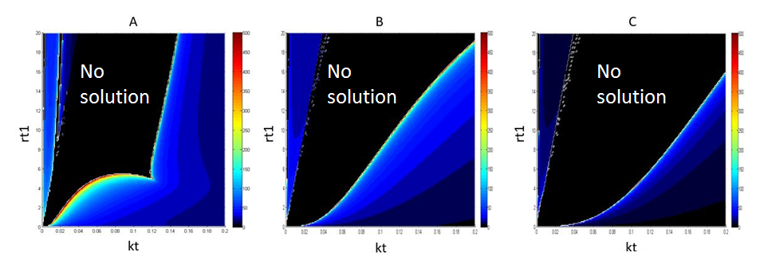

Figure 7. Period graphs; varying kt from 0.001 to 0.2 and rt1 from 0.1 to 20. Color bar: Black is no oscillatory solution, Red is 500 seconds, increments by 50 seconds. The x-axis is kt which varies from 0.001 to 0.2 and the y-axis is rt1 which varies from 0.1 to 20. P0 = A = 1. A) The other 6 parameter values are: kx = 0.1, kp = 0.01, rp1 = 1, rp0 = 1, rx2 = 0.01, and rx0 = 0.1. B) The other 6 parameter values are: : kx = 0.5, kp = 0.05, rp1 = 5, rp0 = 5, rx2 = 0.05, and rx0 = 0.5. C) The other 6 parameter values are: kx = 1, kp = 0.1, rp1 = 10, rp0 = 10, rx2 = 0.1, and rx0 = 1

In Figure 7, it can be seen that the period changes quite a bit with the changes in kt and even the changes in rt1. In Figure 7, the green color is around a period of 200 s, which is the period of interest. This does not stay consistent with Figure 8 which has red at 200 s. The black in Figures 7 & 8 means no oscillatory solutions and therefore, the system will not change during those times. There are many different potential parameter sets and it was decided to pick one for the following analysis and leaving the other sets for future work.

From Figure 7A, the point that was chosen was rt1 = 3.9 and kt = 0.049, which had a period of 202.8 seconds. Since P0 = 1, the whole system is scaled by P0 and the units of the graphs are currently arbitrary. From here, as previously stated, two different parameters are varied in much the same way as rt1 and kt was in the Figure 7.

Figures 7 & 8 have a bifurcation in most of their graphs. A bifurcation is when a red value, or a value with a high period, is right next to a black value, or a value with zero period. This means that there is a border where the system has oscillatory or plausible solutions on one side and not on the other. The other thing that could happen is that the period gradually goes to a very low period, which can be seen when the graph moves from red to yellow to green to blue, and then to dark navy which almost looks black.

Figure 8 is set up in a slightly different way compared to Figure 7. Figure 7 varies two parameters in fine detail and panels A through C are different ranges for the other six parameters. Figure 8 is similar in the idea that two parameters are varied in fine detail, but each panel has two different parameters varied in each of the three panels. This is to expand around that green point chosen in Figure 7 in all six directions. In Figure 8, the color that is being sought out is red, which denotes 200 seconds or more.

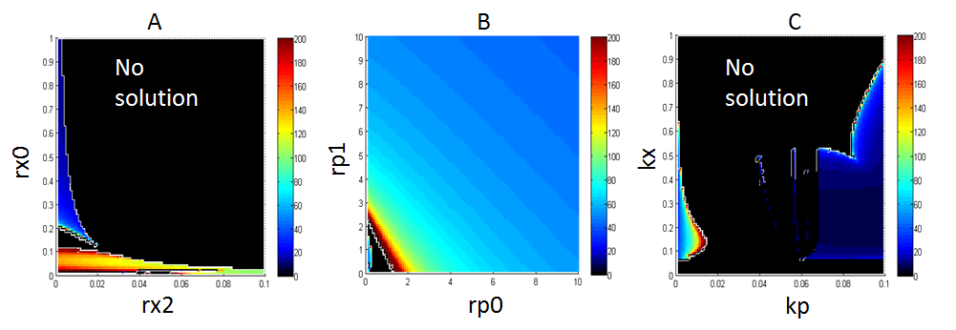

Figure 8. Period graphs; varying rp1 from 1 to 200 and rp0 from 1 to 200. Color bar: Black is no oscillatory solution. Red is 200 seconds, increments by 20 seconds. A = P0 = 1, rt1 = 3.9, and kt = 0.049 (taken from Figure 7A). A) The x-axis is rx2 being varied from 0.001 to 0.1 and the y-axis is rx0 being varied from 0.01 to 1. The other 4 parameter values are: kx = 0.1, kp = 0.01, rp0 = 1, and rp1 = 1. B) The x-axis is rp0 being varied from 0. 1 to 10 and the y-axis is rp1 being varied from 0.1 to 10. The other 4 parameter values are: kx = 0.1, kp = 0.01, rx2 = 0.01, and rx0 = 0.1. C) The x-axis is kp being varied from 0.001 to 0.1 and the y-axis is kx being varied from 0.01 to 1. The other 4 parameter values are: rx0 = 0.1, rx2 = 0.01, rp0 = 1, and rp1 = 1.

The three panels in Figure 8 vary different parameters, as seen above. The parameters were varied around the values set in Figure 7A, and this is where the green point was taken from. The parameters were varied from one tenth the value of the parameter in Figure 7A to ten times the value found in Figure 7A. It is to no surprise that the plausible solutions, solutions with periods near 200 seconds, are found in the lower left corner of each graph. This area denotes the values close to the value found in Figure 7A. However, there are a larger variety of points that have periods near 200 seconds and this gives us a broader spectrum of data to work with.

The model that was created, Figure 5 and equations 1-3, does have oscillatory solutions that meet our selection criteria. The solutions do oscillate and have a period which satisfies the two physical criteria to be considered potential solutions. However, the fact that there are 10 parameters to deal with means that many potential solutions will be found, as shown by the fact that Figure 7A already has over 100 solutions. A computer simulation of these signals interacting in a 2D membrane will have to run through all of the potential solution to figure out which best fits the experimental system.

**REFERENCES**

Arai, Y., Shibata, T., Matsuoka, S., Sato, M. J., Yanagida, T., & Ueda, M. (2010). Self-organization of the phosphatidylinositol lipids signaling system for random cell migration. *Proceedings of the National Academy of Sciences of the United States of America*, *107*(27), 12399–12404. http://doi.org/10.1073/pnas.0908278107

Bretschneider, T., Anderson, K., Ecke, M., Müller-Taubenberger, A., Schroth-Diez, B., Ishikawa-Ankerhold, H. C., & Gerisch, G. (2009). The Three-Dimensional Dynamics of Actin Waves, a Model of Cytoskeletal Self-Organization. *Biophysical Journal*, *96*(7), 2888–2900. http://doi.org/10.1016/j.bpj.2008.12.3942

Cell Migration Gateway. (2014). Migration 101 - An Introduction to Cell Migration. Retrieved January 5, 2016, from https://www.cellmigration.org/science/

CNU. (n.d.). Chapter 11 Cytoskeleton System. Retrieved January 18, 2016, from http://greatcourse.cnu.edu.cn/xbswx/wlkc/kcxx/10english%20ppt(19268096bytes).htm

Gerhardt, M., Ecke, M., Walz, M., Stengl, A., Beta, C., & Gerisch, G. (2014). Actin and PIP3 waves in giant cells reveal the inherent length scale of an excited state. *Journal of Cell Science*, *127*(Pt 20), 4507–4517. http://doi.org/10.1242/jcs.156000

Gerisch, G., Bretschneider, T., Müller-Taubenberger, A., Simmeth, E., Ecke, M., Diez, S., & Anderson, K. (2004). Mobile Actin Clusters and Traveling Waves in Cells Recovering from Actin Depolymerization. *Biophysical Journal*, *87*(5), 3493–3503. http://doi.org/10.1529/biophysj.104.047589

Gerisch, G., Schroth-Diez, B., Müller-Taubenberger, A., & Ecke, M. (2012). PIP3 waves and PTEN dynamics in the emergence of cell polarity. *Biophysical Journal*, *103*(6), 1170–1178. http://doi.org/10.1016/j.bpj.2012.08.004

Knoch, F., Tarantola, M., Bodenschatz, E., & Rappel, W.-J. (2014). Modeling self-organized spatio-temporal patterns of PIP₃ and PTEN during spontaneous cell polarization. *Physical Biology*, *11*(4), 046002. http://doi.org/10.1088/1478-3975/11/4/046002

Lodish, H., Berk, A., Zipursky, S. L., Matsudaira, P., Baltimore, D., & Darnell, J. (2000). *Molecular Cell Biology* (4th ed.). W. H. Freeman.

MBInfo Wiki. (2015, May 25). Actin filament polymerization. Retrieved January 6, 2016, from http://www.mechanobio.info/modules/go-0030041

Slideshare. (2012, November). *Tang 01 organic chemistry and alkanes*. Retrieved from http://www.slideshare.net/mrtangextrahelp/tang-01-organic-chemistry-and-alkanes

**GLOSSARY**

|  |  |  |
| --- | --- | --- |
| Dict D |  | Dictyostelium Discoideum: Slime molds: basic eukaryotic cell |
| Lat A |  | Latrunculin A: a drug that depolymerizes the actin filaments. |
| PIP3 |  | Phosphatidylinositol [3,4,5] tris-phosphate: a lipid found in Dict D. |
| PTEN |  | Phosphatase tensin homolog: an enzyme found in Dict D. |